**Assignment - 2**

**Name: Sammed Singalkar**

**Roll No: B-58**

**Batch: BC-4**

**Describe black box testing and white box testing in detail**

**Ans:-**

**Black Box Testing**

* Black Box Testing is a software testing method in which the internal structure/design/implementation of the item being tested is not known to the tester. Only the external design and structure are tested.
* It is a way of software testing in which the internal structure or the program or the code is hidden and nothing is known about it.
* Implementation of code is not needed for black box testing.
* It is mostly done by software testers.
* No knowledge of implementation is needed.
* It can be referred as outer or external software testing.
* It is functional test of the software.
* This testing can be initiated on the basis of requirement specifications document.

Black box testing involves testing a system with no prior knowledge of its internal workings. A tester provides an input, and observes the output generated by the system under test. This makes it possible to identify how the system responds to expected and unexpected user actions, its response time, usability issues and reliability issues.

Black box testing is a powerful testing technique because it exercises a system end-to-end. Just like end-users “don’t care” how a system is coded or architected, and expect to receive an appropriate response to their requests, a tester can simulate user activity and see if the system delivers on its promises. Along the way, a black box test evaluates all relevant subsystems, including UI/UX, web server or application server, database, dependencies, and integrated systems.

An example of a [security technology that performs black box testing is Dynamic](https://www.imperva.com/learn/data-security/information-security-infosec/)[Application Security Testing](https://www.imperva.com/learn/application-security/application-security/)(DAST), which tests products in staging or production and provides feedback on compliance and security issues.

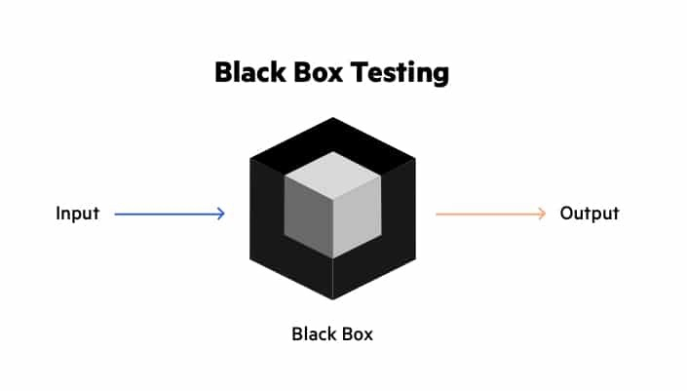

**Types Of Black Box Testing**

Black box testing can be applied to three main types of tests: functional, non-functional, and regression testing.

**Functional Testing**

Black box testing can test specific functions or features of the software under test. For example, checking that it is possible to log in using correct user credentials, and not possible to log in using wrong credentials.

Functional testing can focus on the most critical aspects of the software (smoke testing/sanity testing), on integration between key components (integration testing), or on the system as a whole (system testing).

**Non-Functional Testing**

Black box testing can check additional aspects of the software, beyond features and functionality. A non-functional test does not check “if” the software can perform a specific action but “how” it performs that action.

Black box tests can uncover if software is:

* Usable and easy to understand for its users
* Performant under expected or peak loads
* Compatible with relevant devices, screen sizes, browsers or operating systems
* Exposed to security vulnerabilities or common security threats

**Regression Testing**

Black box testing can be used to check if a new version of the software exhibits a regression, or degradation in capabilities, from one version to the next. Regression testing can be applied to functional aspects of the software (for example, a specific feature no longer works as expected in the new version), or non-functional aspects (for example, an operation that performed well is very slow in the new version).

**White Box Testing**

* White Box Testing is a software testing method in which the internal structure/design/implementation of the item being tested is known to the tester. Implementation and impact of the code are tested.
* It is a way of testing the software in which the tester has knowledge about the internal structure or the code or the program of the software.
* Code implementation is necessary for white box testing.
* It is mostly done by software developers.
* Knowledge of implementation is required.
* It is the inner or the internal software testing.
* It is structural test of the software.
* This type of testing of software is started after detail design document.
* It is mandatory to have knowledge of programming.
* It is the logic testing of the software.
* It is generally applicable to the lower levels of software testing.
* It is also called as clear box testing.

White box testing is an approach that allows testers to inspect and verify the inner workings of a software system—its code, infrastructure, and integrations with external systems. White box testing is an essential part of automated build processes in a modern Continuous Integration/Continuous Delivery (CI/CD) development pipeline.

White box testing is often referenced in the context of Static Application Security Testing (SAST), an approach that checks source code or binaries automatically and provides feedback on bugs and possible vulnerabilities.

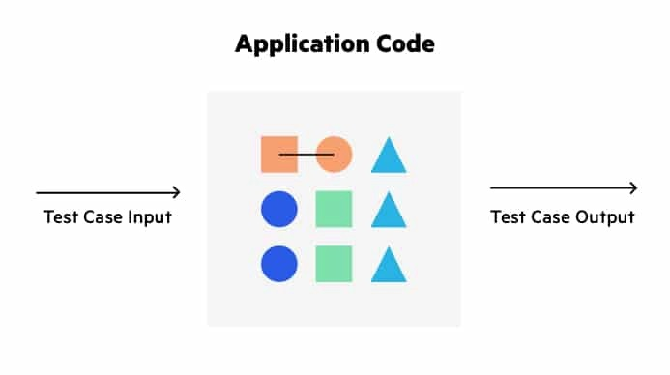

**Types of White Box Testing**

White box testing can take several forms:

* **Unit testing** — tests written as part of the application code, which test that each component is working as expected.
* **Mutation testing** — a type of unit testing that checks the robustness and consistency of the code by defining tests, making small, random changes to the code and seeing if the tests still pass.
* **Integration testing** — tests specifically designed to check integration points between internal components in a software system, or integrations with external systems.
* **White box penetration testing** — an ethical hacker acts as a knowledgeable insider, attempting to attack an application based on intimate knowledge of its code and environment.
* **Static code analysis** — automatically identifying vulnerabilities or coding errors in static code, using predefined patterns or machine learning analysis.